ASSIGNMENT 2

DATE 09 /08

RITESH KUMAR CHAURASIYA

QUESTION 1

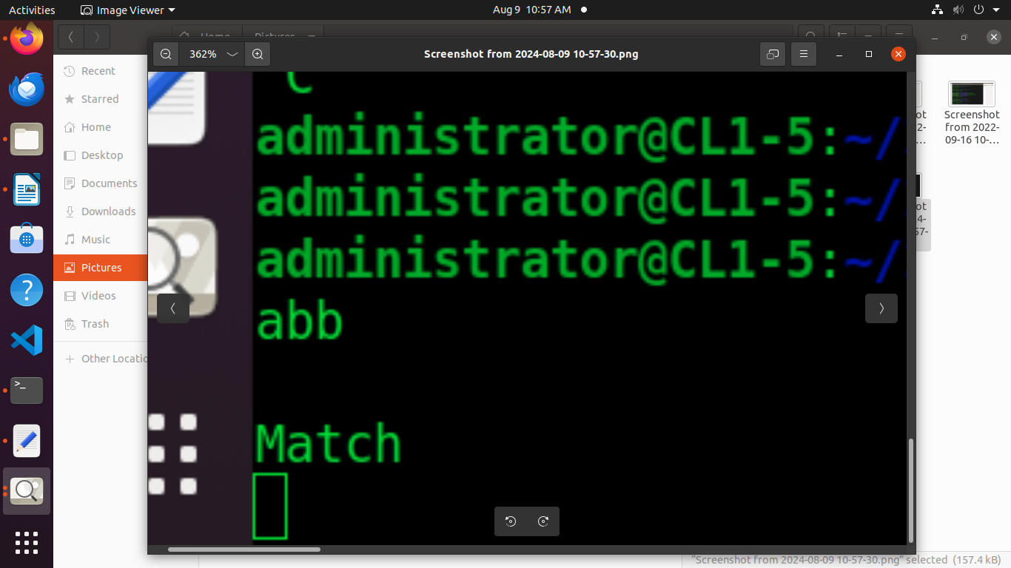
/* just like Unix wc */
%{

%}
%%

(a|b)*abb$ { printf("\nMatch"); }
%%
int main(int argc, char **argv)
{

yylex();
return 0;
}

QUESTION 2

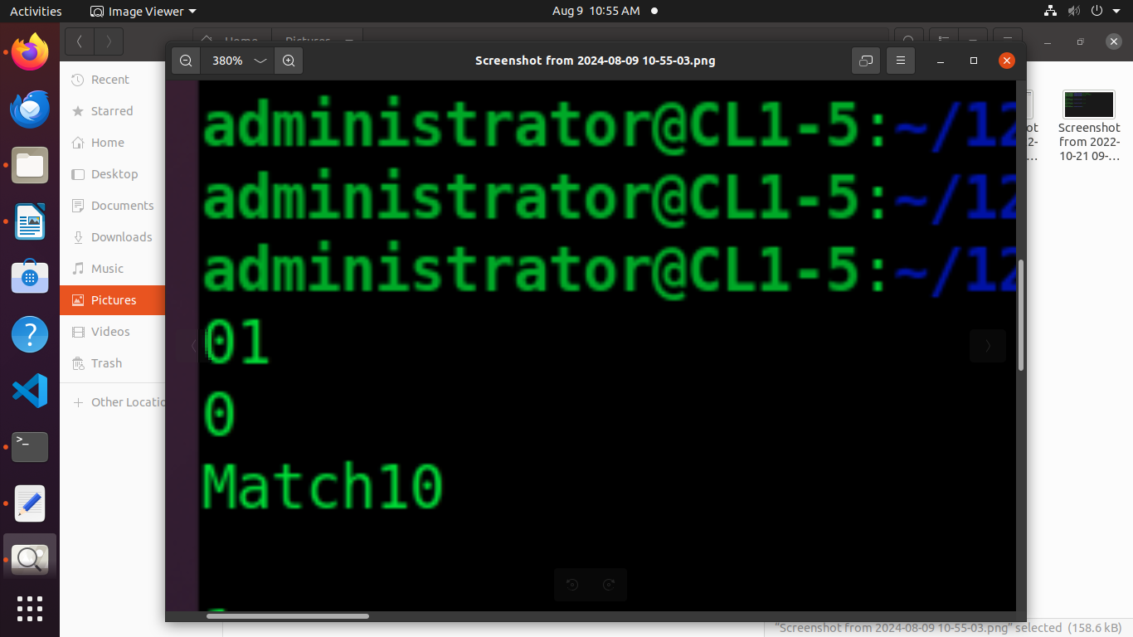
%{
%}
%%

((00)*+(11)*+1)$ {printf("\nMatch");}
.|\n$ {printf("\nNot Match");}
%%
int main(int argc,char **argv)
{
yylex();
return 0;
}

I HAVE USED ONLY THE ONE PERMUTATION , THERE IS TOTAL 8 PERMUTATIONS

QUESTION 3

/* just like Unix wc */
%{
#include<stdio.h>
int n = 0;
%}
%%

(ONE) {n=n+1;}
(TWO) {n=n+2;}
(THREE) {n=n+3;}
(FOUR) {n=n+4;}
(FIVE) {n=n+5;}
(SIX) {n=n+6;}
(SEVEN) {n=n+7;}
(EIGHT) {n=n+8;}
(NINE) {n=n+9;}
(TEN) {n=n+10;}
(ELEVEN) {n=n+11;}
(TWELVE) {n=n+12;}
(THIRTEEN) {n=n+13;}
(FOURTEEN) {n=n+14;}
(FIFTEEN) {n=n+15;}
(SIXTEEN) {n=n+16;}
(SEVENTEEN) {n=n+17;}
(EIGHTEEN) {n=n+18;}
(NINTEEN) {n=n+19;}
(TWENTY) {n=n+20;}
(THIRTY) {n=n+30;}
(FORTY) {n=n+40;}
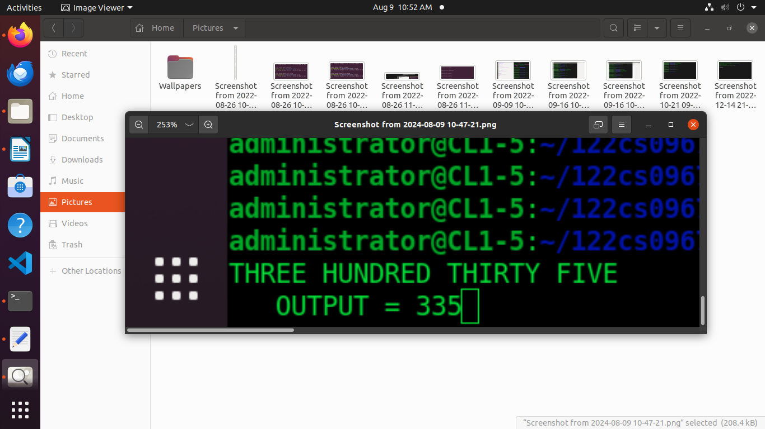
(FIFTY) {n=n+50;}
(SIXTY) {n=n+60;}
(SEVENTY) {n=n+70;}
(EIGHTY) {n=n+80;}
(NINETY) {n=n+90;}
(HUNDRED) {n=n*100;}
\n {printf("OUTPUT = %d",n); n=0;}

%%
int main(int argc, char **argv)
{
yylex();
return 0;
}

